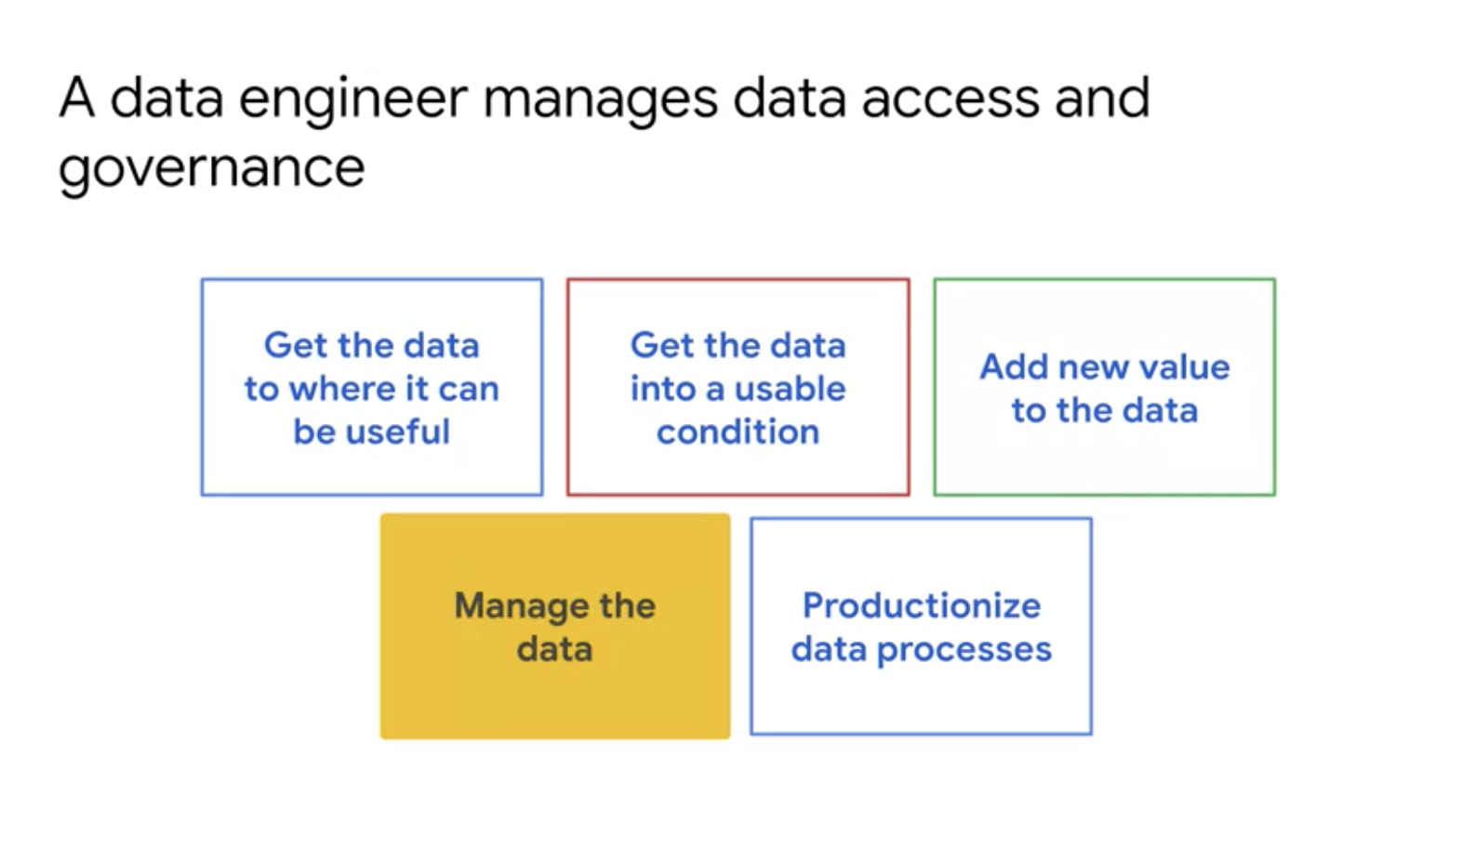

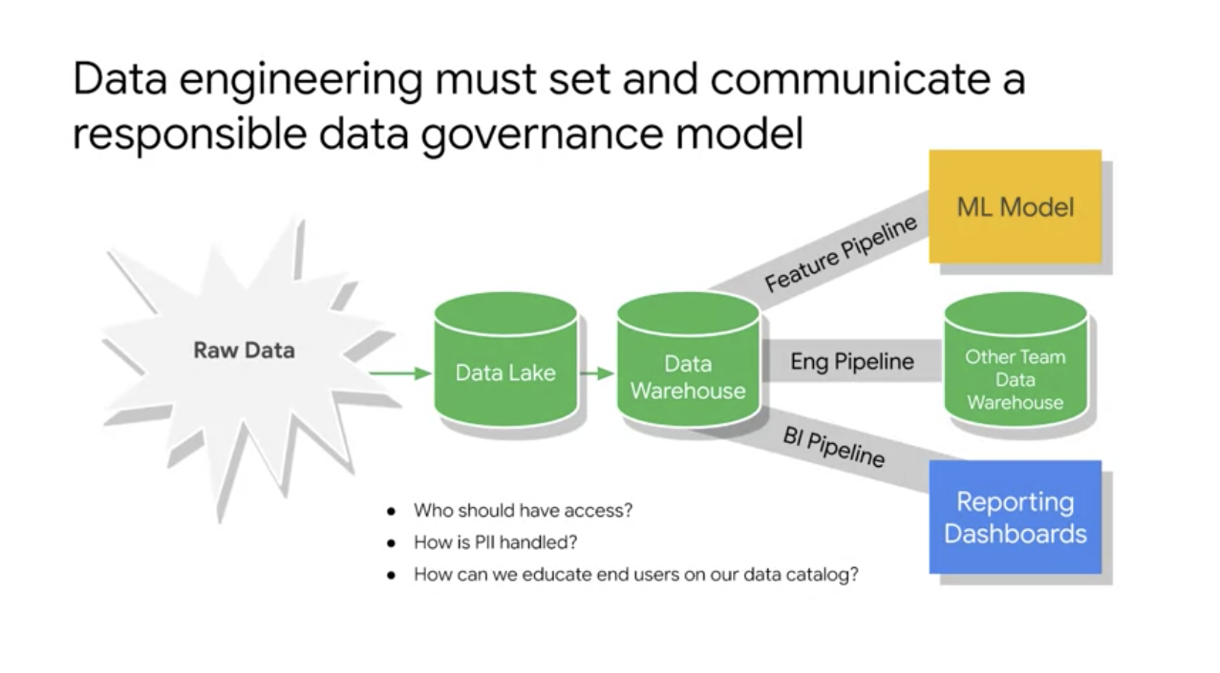

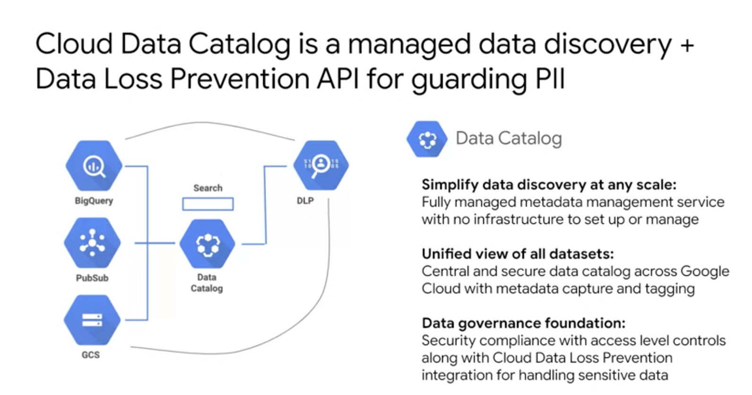

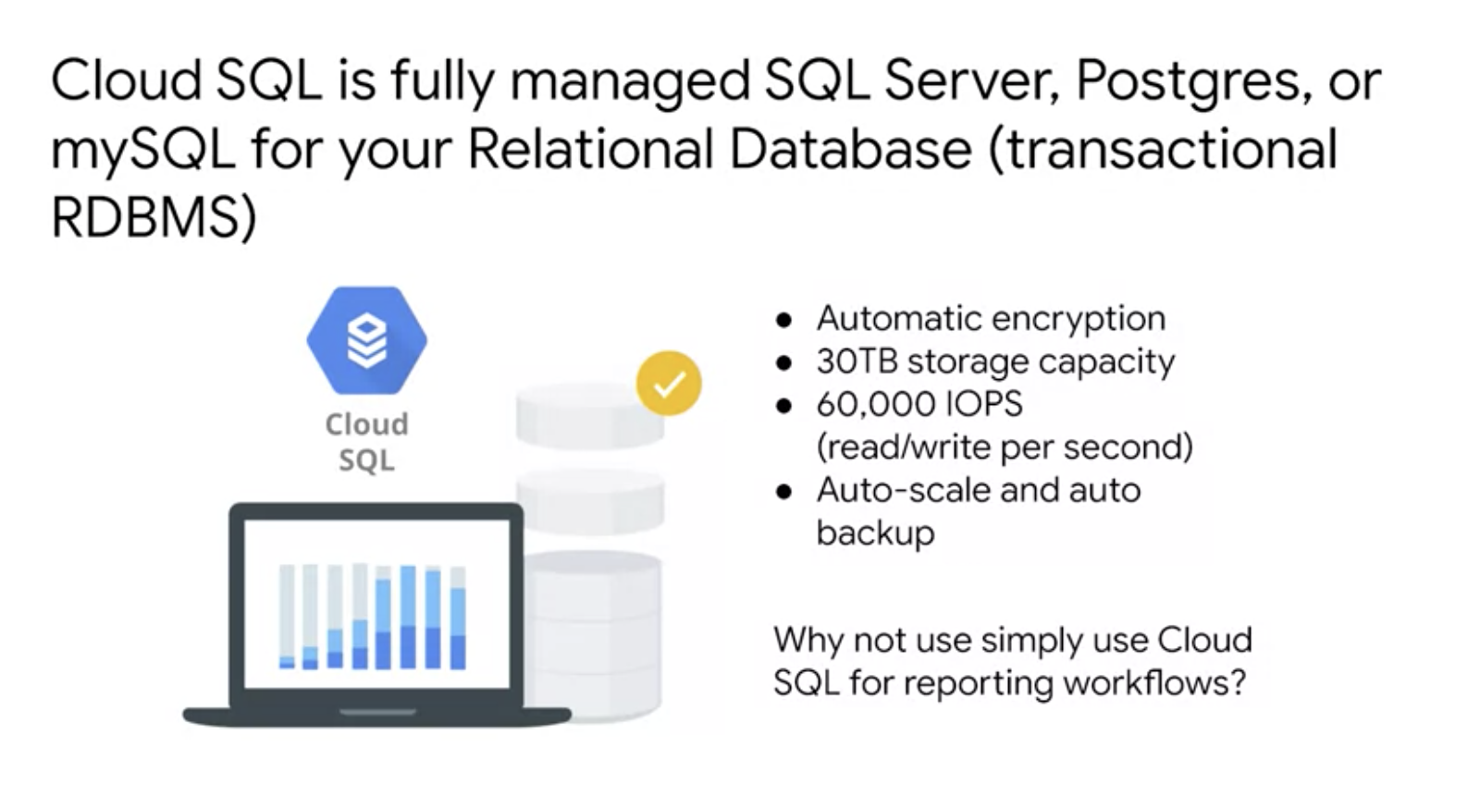

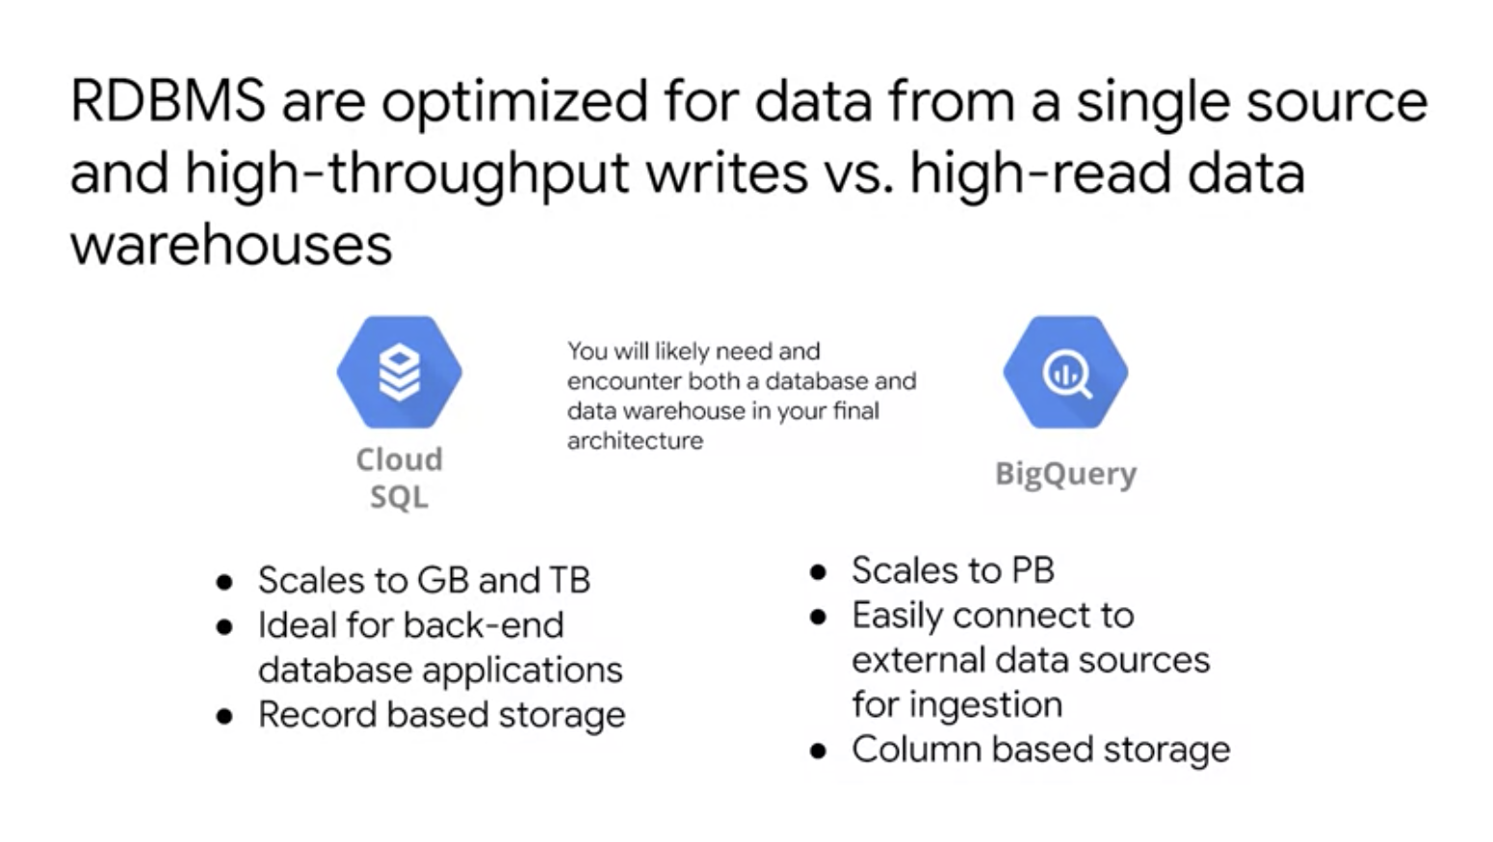

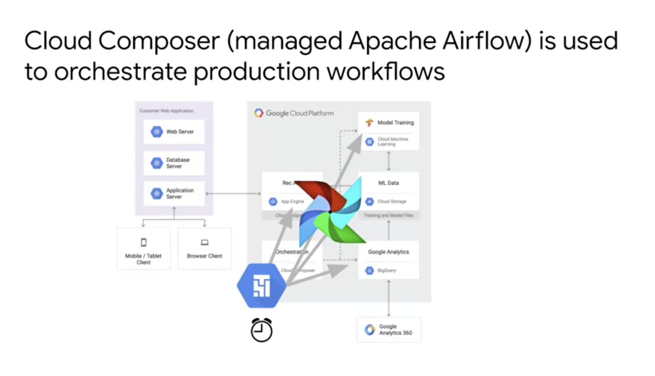

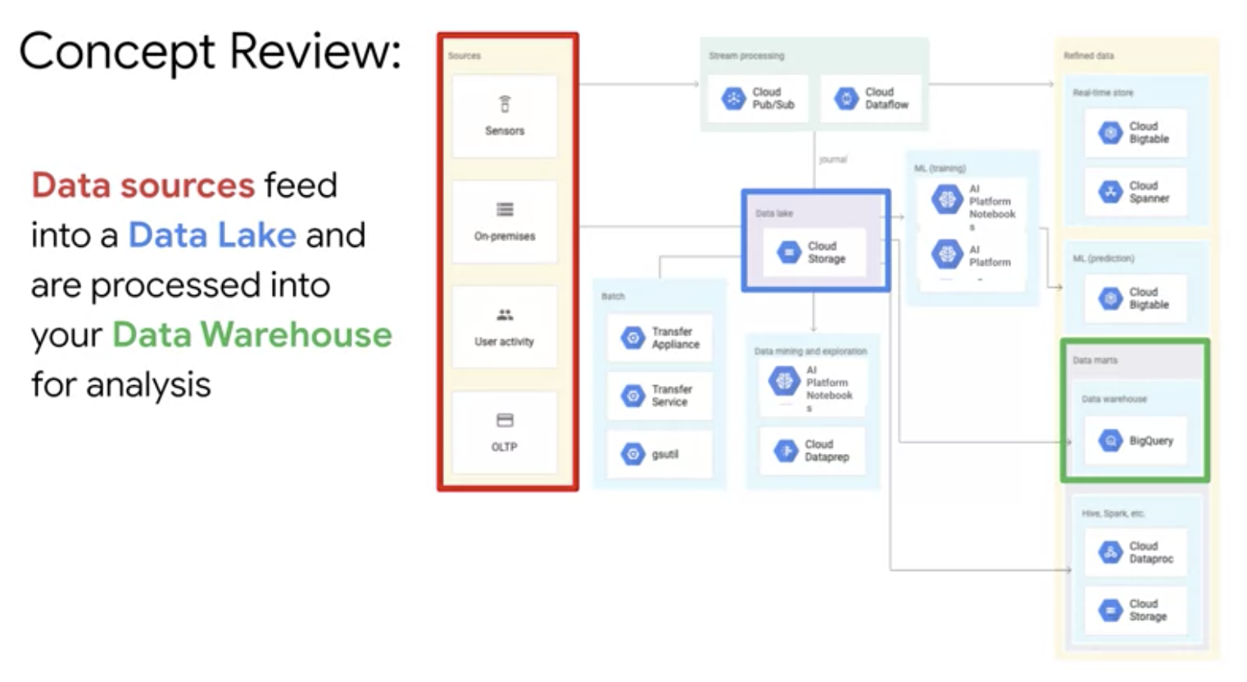

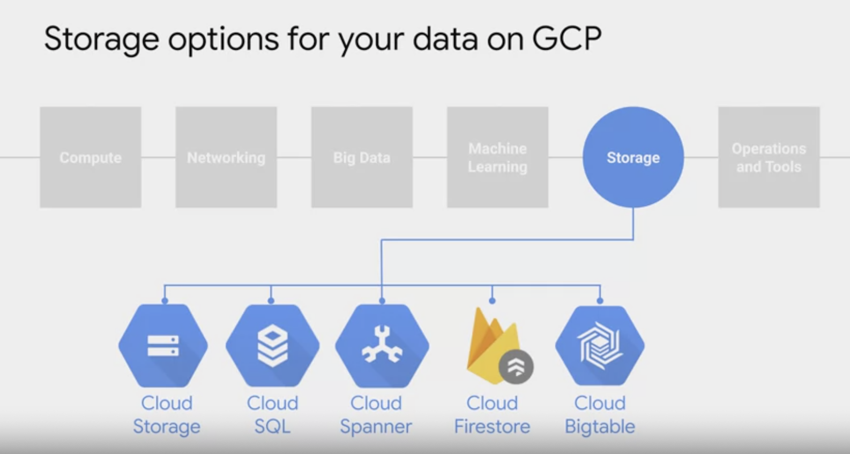

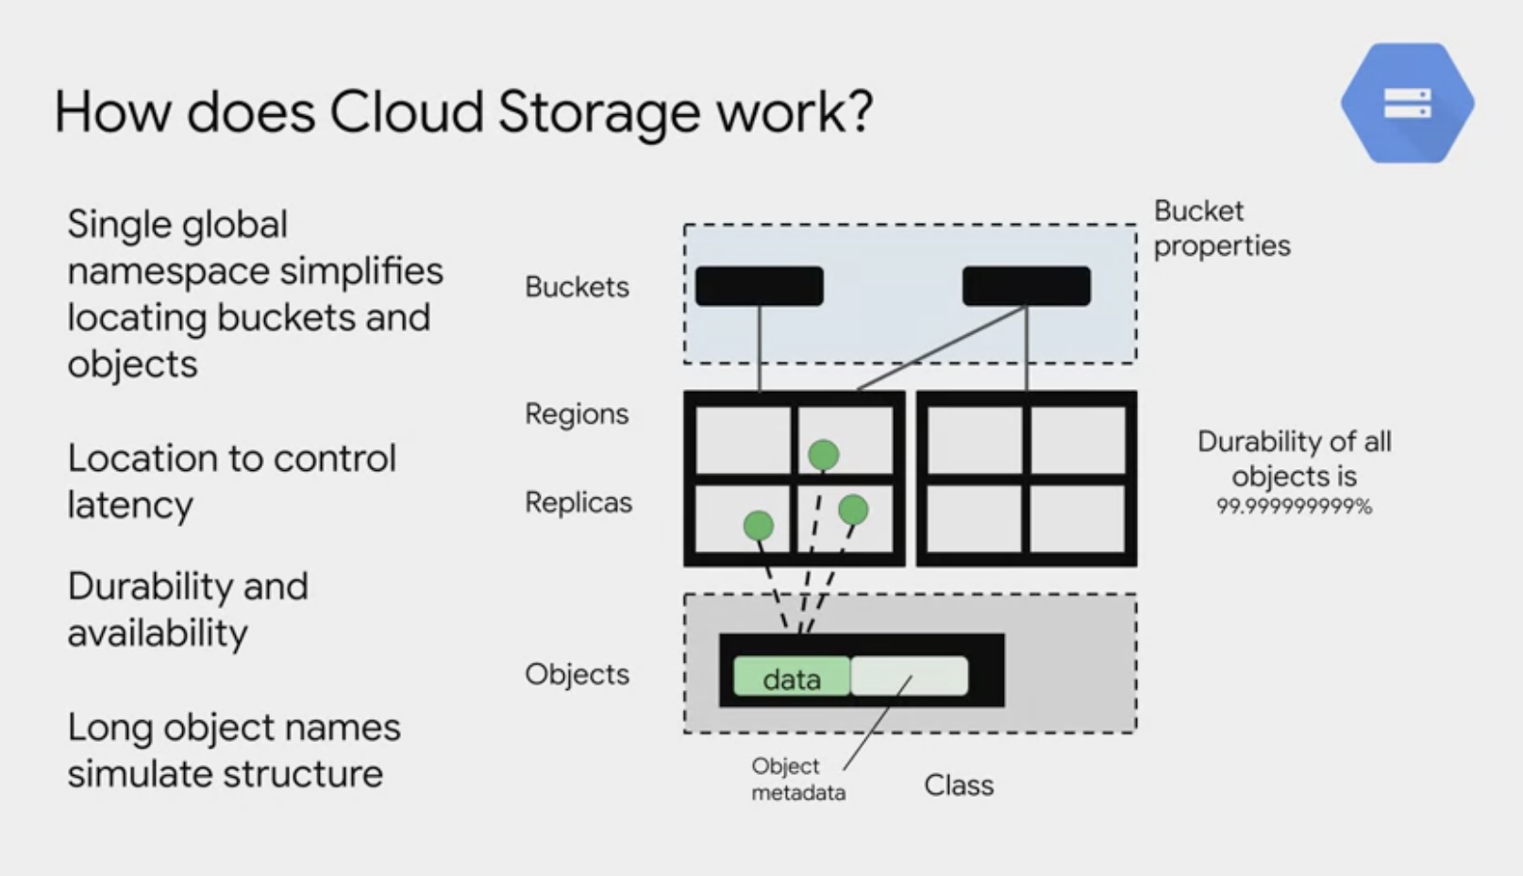

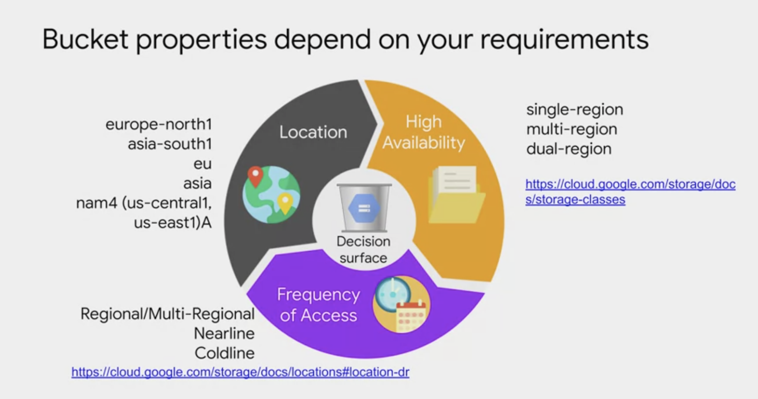

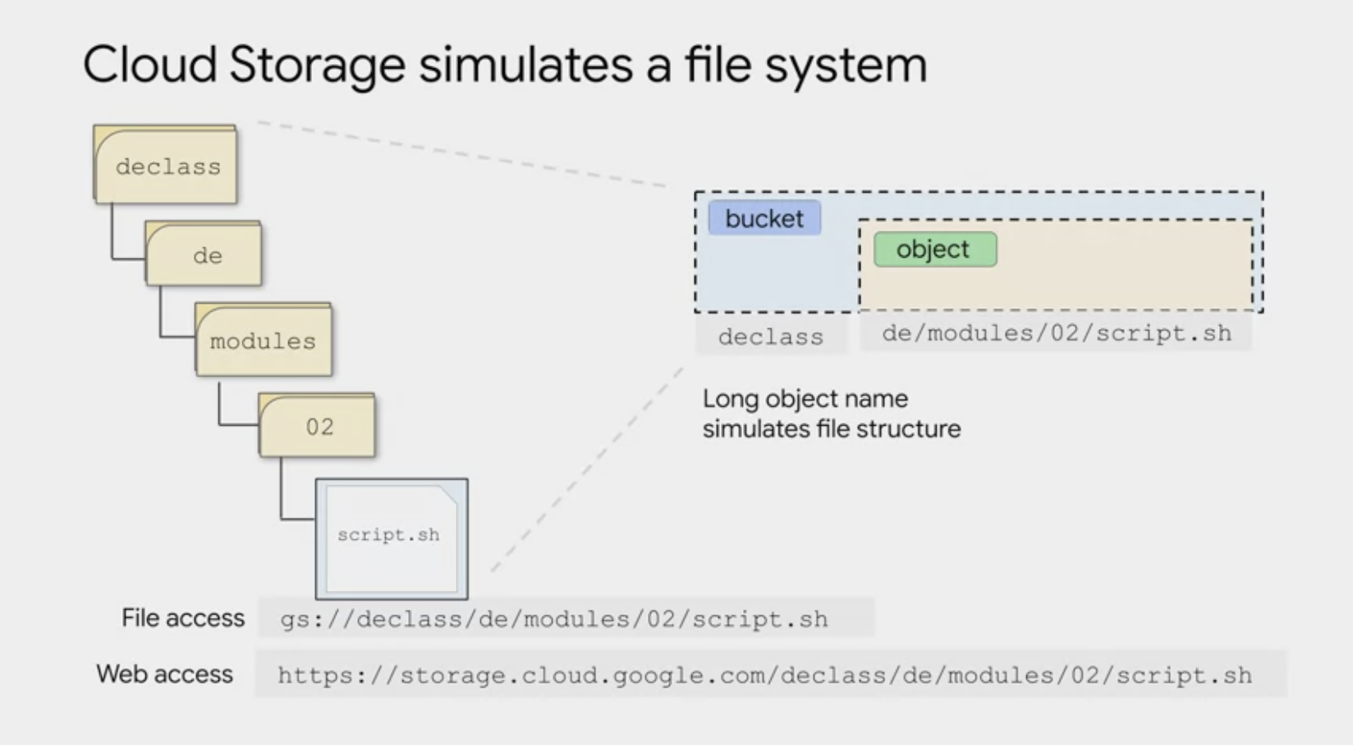

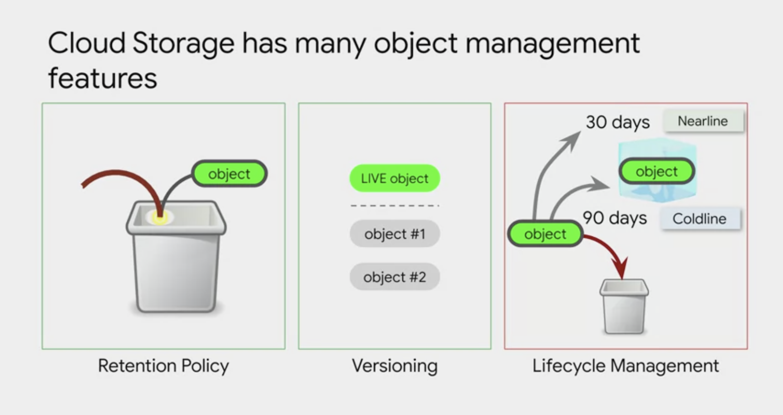

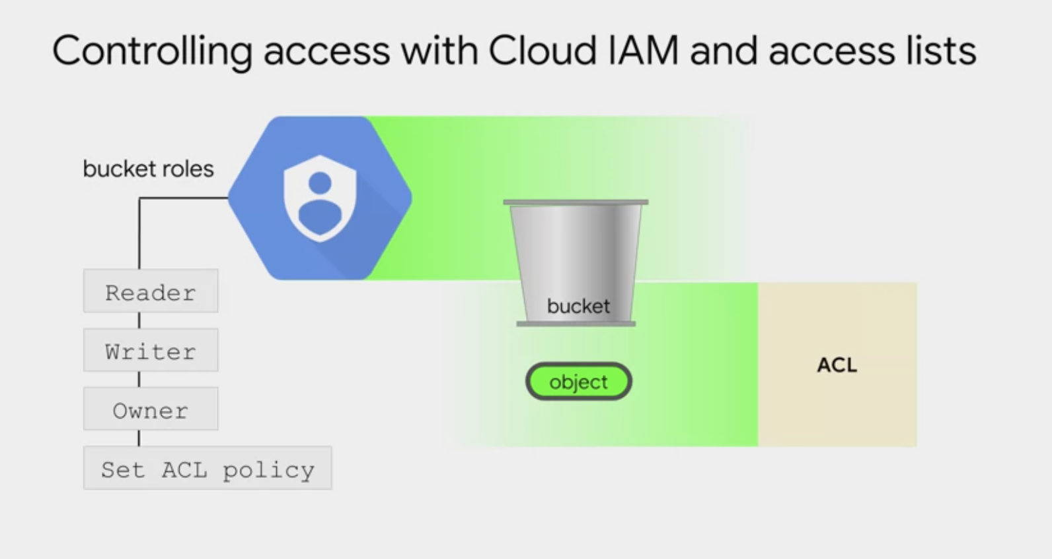

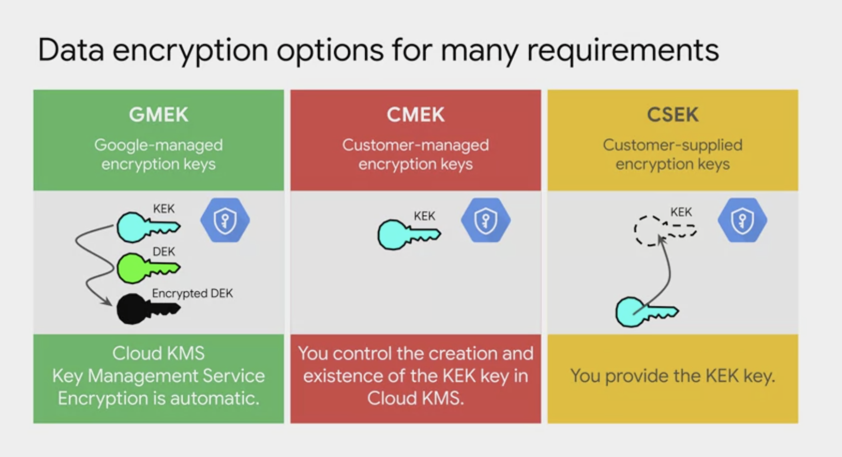

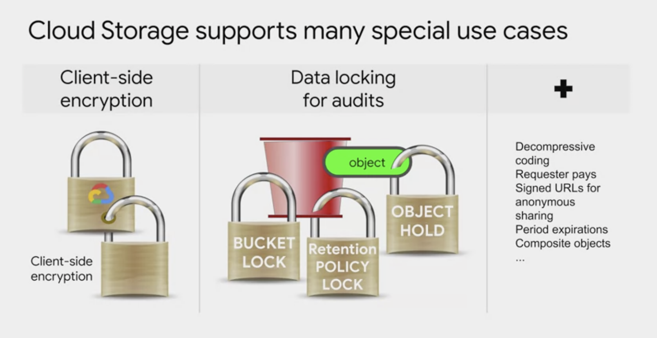

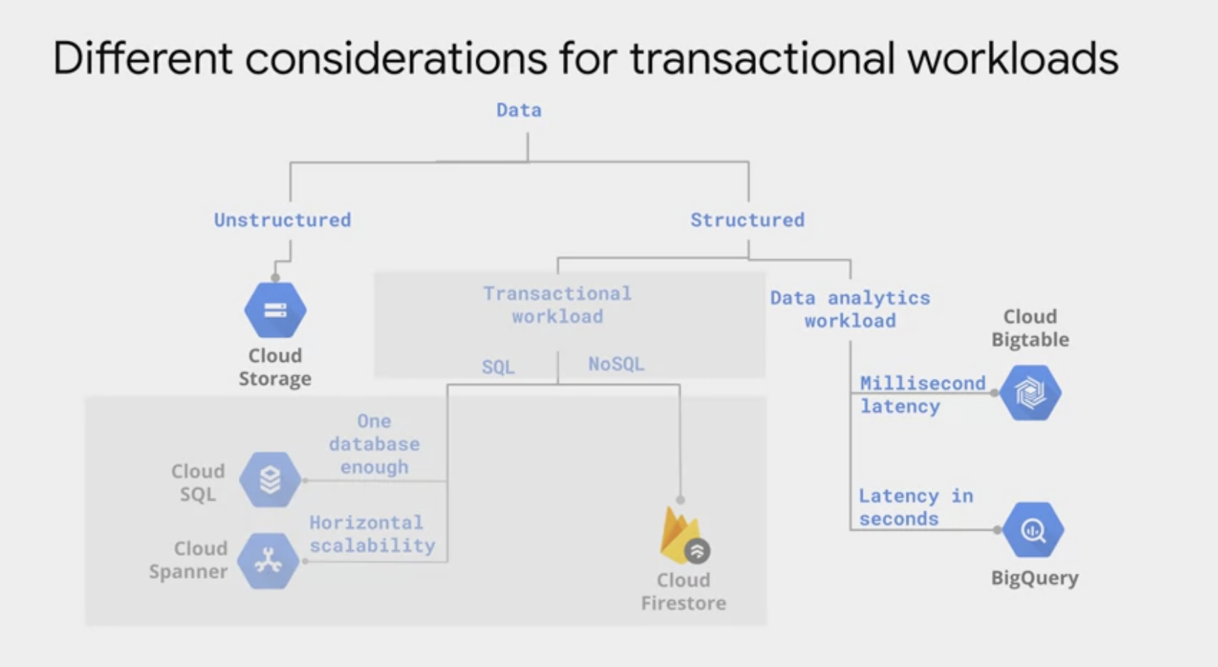

On Google Cloud, a data warehouse option that's very popular tends to be BigQuery.

There is a limit to the size of the data that can be loaded directly into BigQuery. This is because your network might affect that bottleneck.

Rather than load the data directly into BigQuery, it can be much more convenient to first stage it and load it into Google Cloud Storage is that data lake, and then load Google Cloud Storage through a pipeline into BigQuery as your data warehouse.

This is because Google Cloud Storage supports a multithreaded resumable loads of data.

If you're using gsutil, you can literally just provide a -m option there.

Loading data from Cloud Storage will also be much faster because of the high throughput it offers.

A feature that has recently been released is the ability for BigQuery to query data files that live in Google Cloud Storage, directly query them without having to first load

those files into BigQuery zone native storage. This is called a **federated query** or

creating an external data source connection.

A super popular use case is if you have your data files in a variety of formats like CSV,

Avro, newly supported you can do Parquet or Apache ORC, and then query them directly into BigQuery.

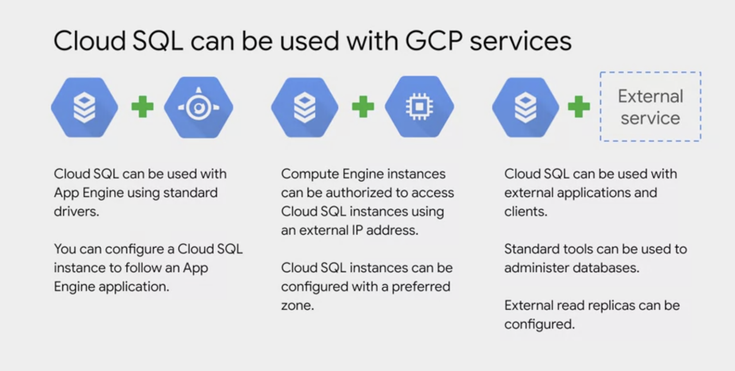

We kept saying that cloud SQL is fully managed. You might also seen us use the word serverless to describe like **BigQuery**.

**For example**, what's the difference between fully managed and serverless?

By fully managed, we mean that the service runs on a hardware that you can control, you can SSH into a Cloud SQL instance for example. That said, Google does help you manage that instance by automating backups and setting over those failover instances that we just talked about. Serverless is the next step up, you can treat a serverless product that's just like an API that you're calling, sure you pay for using the product, but you don't have to worry about or manage any of the servers, for all you know, it could be completely manual behind the scenes, you just get the benefits of the output. BigQuery is serverless, as is cloud pub/sub for asynchronous messaging and data flow for parallel data processing, you can think of cloud storage as being serverless as well. Sure cloud storage uses discs, but you never actually have to interact with any of the hardware.

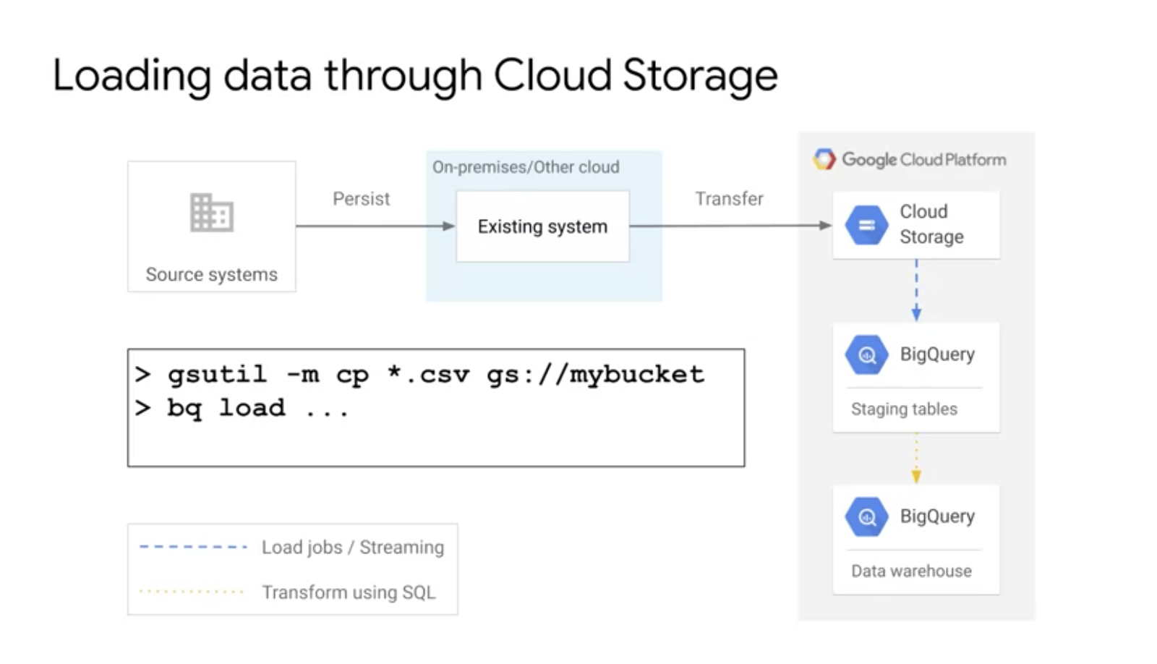

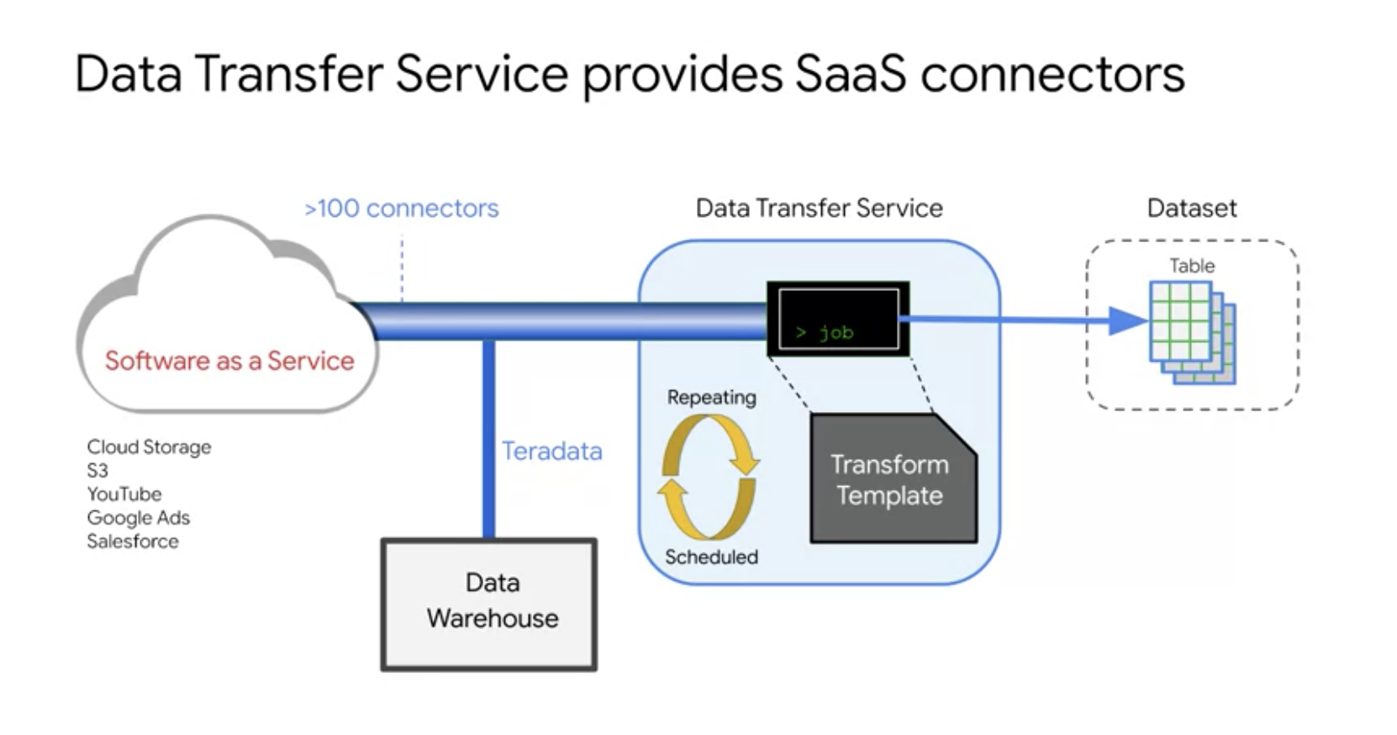

**Introduction to ARRAYs and STRUCTs**

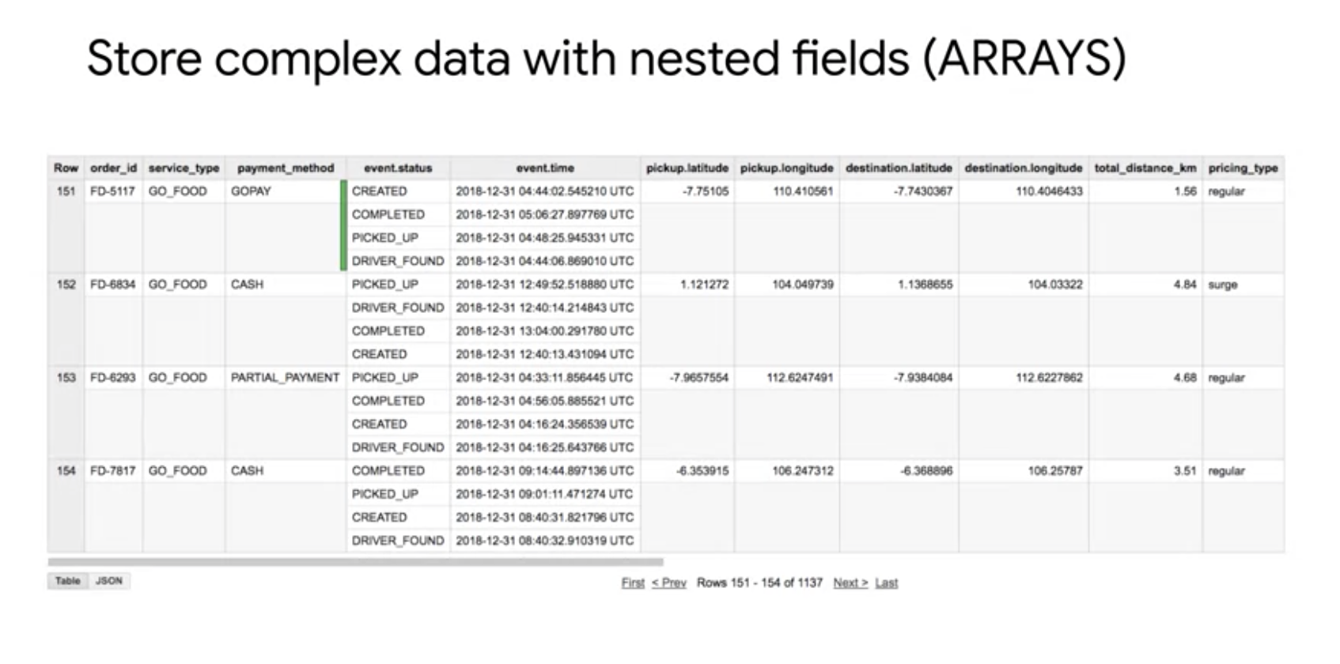

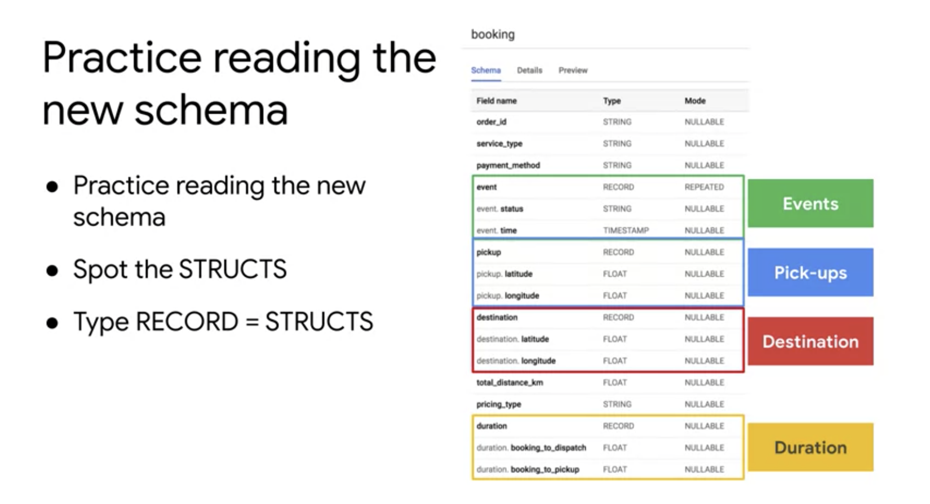

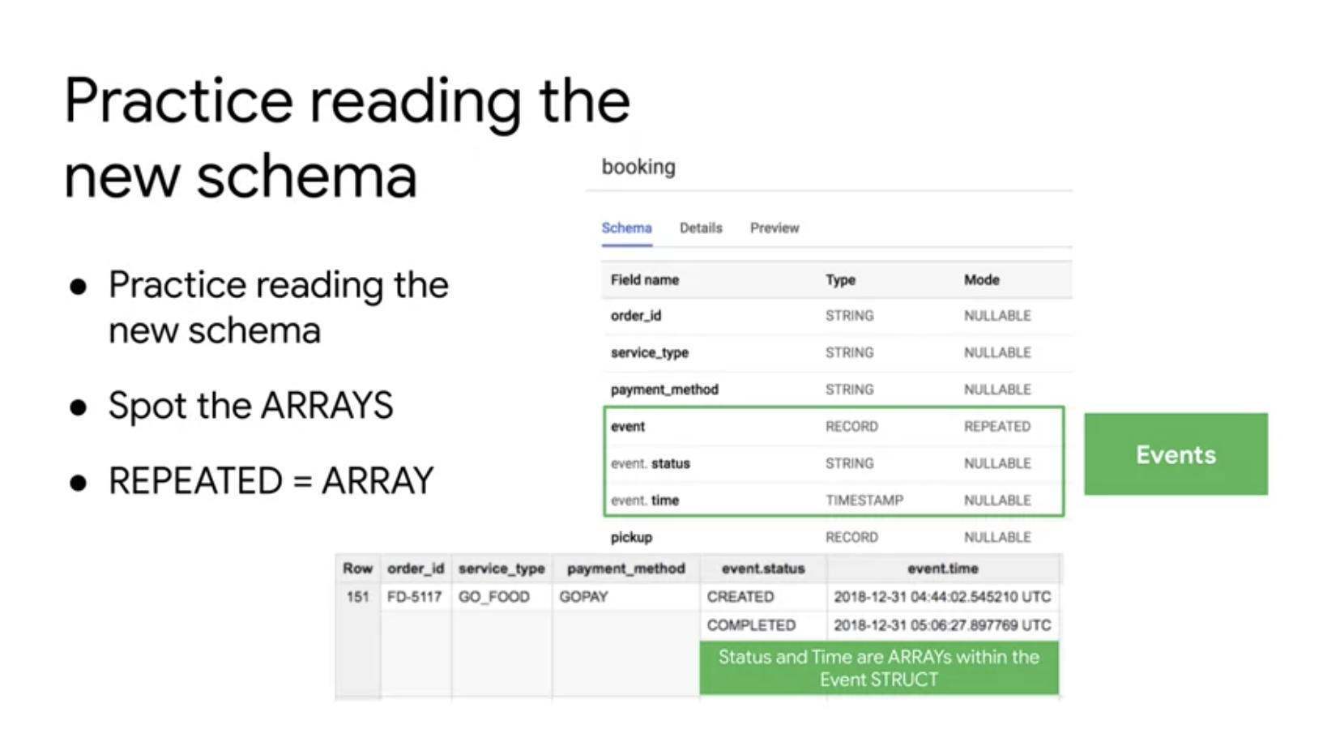

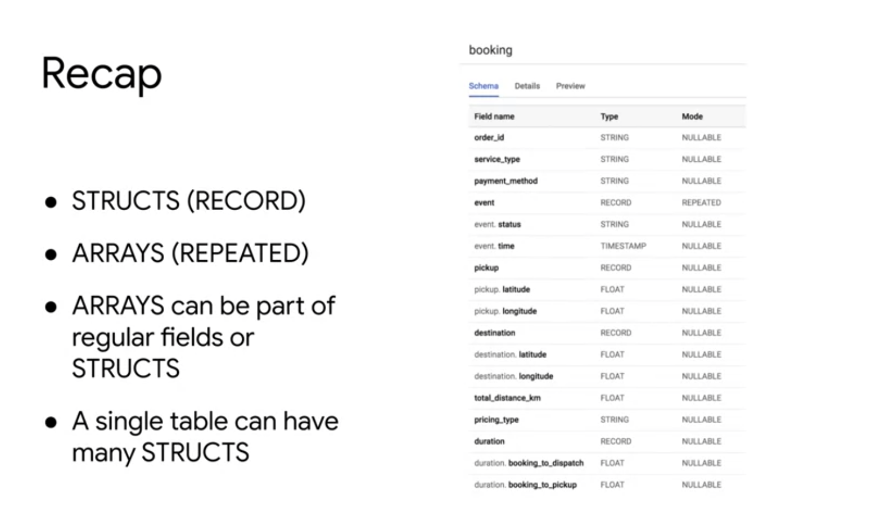

You may have wondered why the field alias hit.page.pageTitle looks like three fields in one separated by periods. Just as ARRAY values give you the flexibility to *go deep* into the granularity of your fields, another data type allows you to *go wide* in your schema by grouping related fields together. That SQL data type is the [STRUCT](https://cloud.google.com/bigquery/docs/reference/standard-sql/data-types#struct-type) data type.

The easiest way to think about a STRUCT is to consider it conceptually like a separate table that is already pre-joined into your main table.

A STRUCT can have:

* one or many fields in it
* the same or different data types for each field
* it's own alias

